**Module 1_ AWS_Fundamentals_Cloud**

===============================================================================================

Submitted to Vikul_Sir

Submitted by Nalathati Rahul

Submission Date – 03/Feb/2026

===============================================================================================

1. **L1 - Demonstrate the AWS EC2 Ubuntu Instance Creation steps and connect to EC2 Instance using Mobaxterm/putty agent**

Step 1: Go to AWS URL 🡪 <https://aws.amazon.com/console/> 🡪and login with Credentials

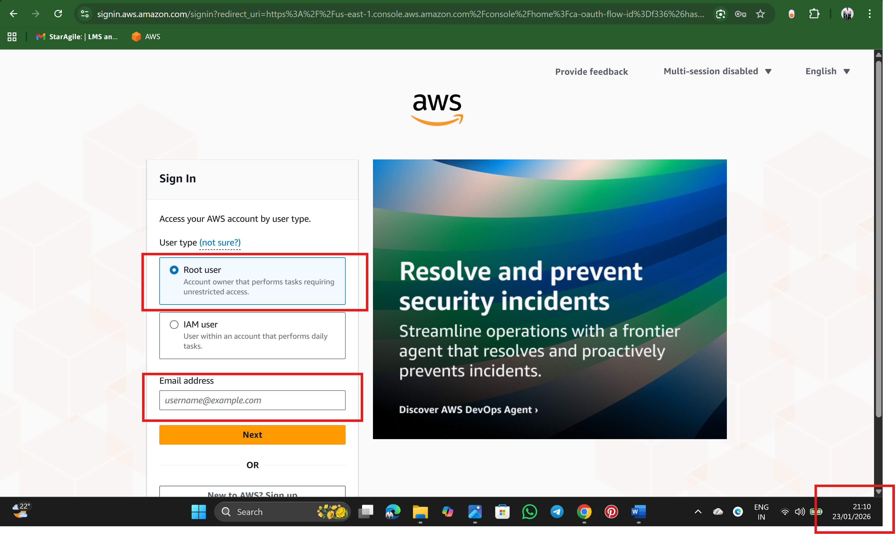

Step 2: After login Search for EC2 Service on AWS Search Bar

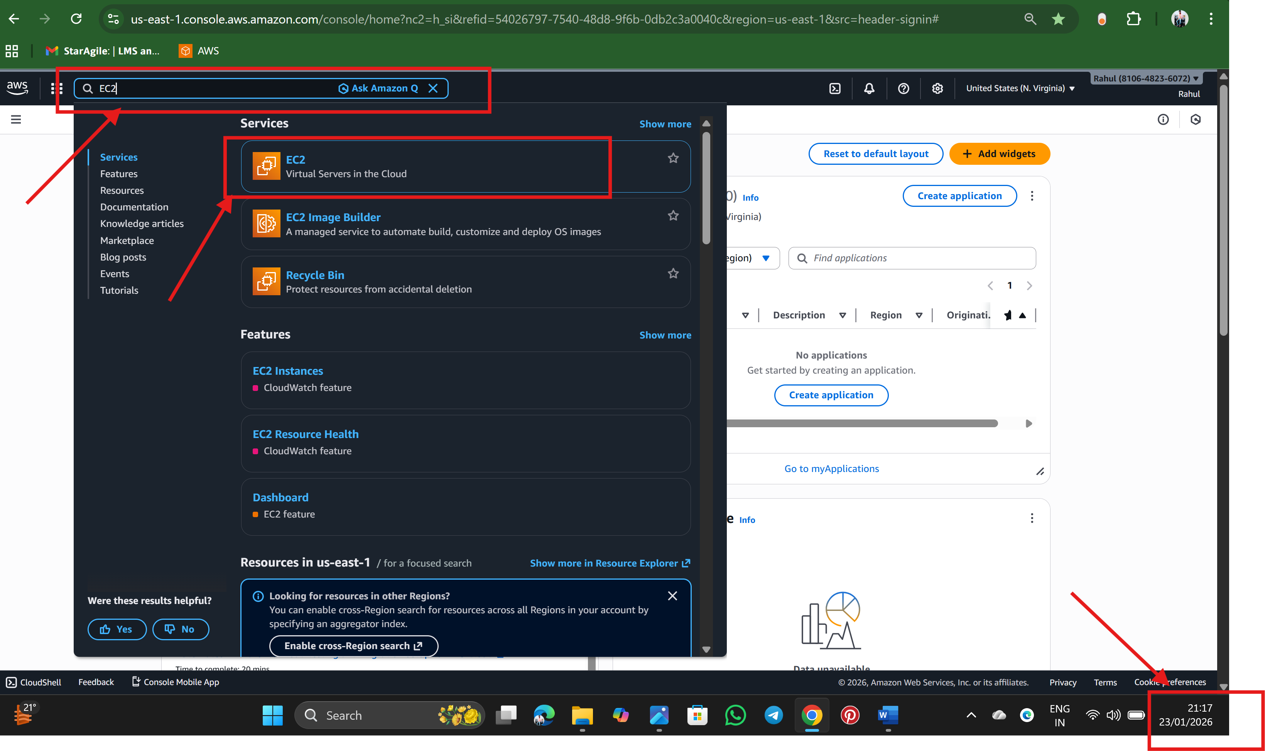



Step 3: Interface of EC2 Dashboard 🡪 click on Launch Instance

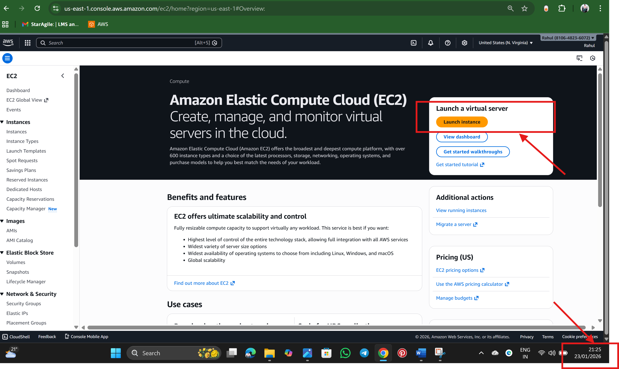

Step 4: Enter a Instance name (example: Ubuntu-Server)

🡪Choose AMI (Amazon Machine Image) and Select (Free Tier eligible) since it is a free trail account  
 “AMI is an OS for our server”

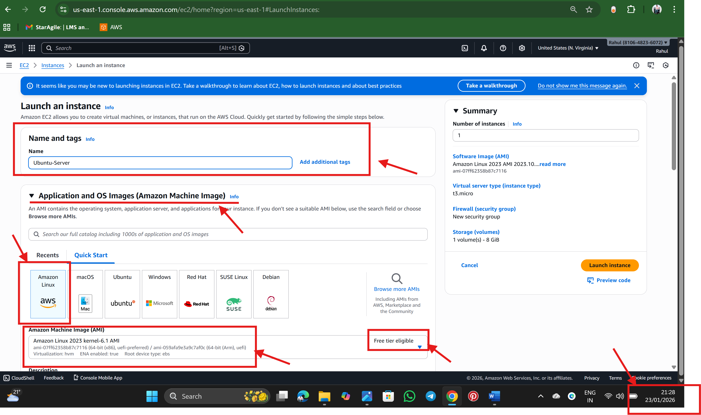

Step 5: Choose Instance Type

🡪Select t2.micro which come in Free Tier eligible  
 Instance type is know as computing power for our server

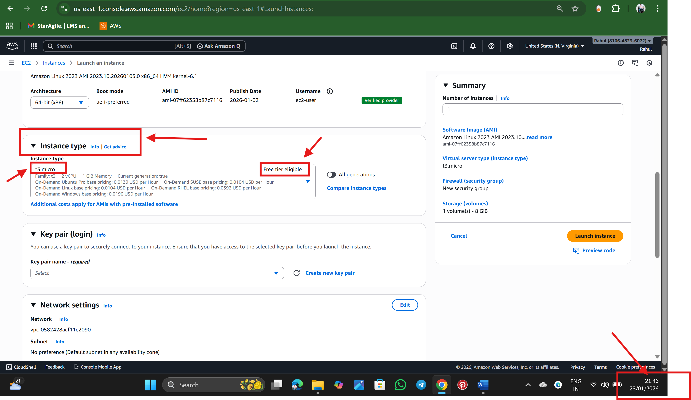

Step 6: Select a Key pair if not Create One   
 🡪 Key pair is used to connect to server securely  
  
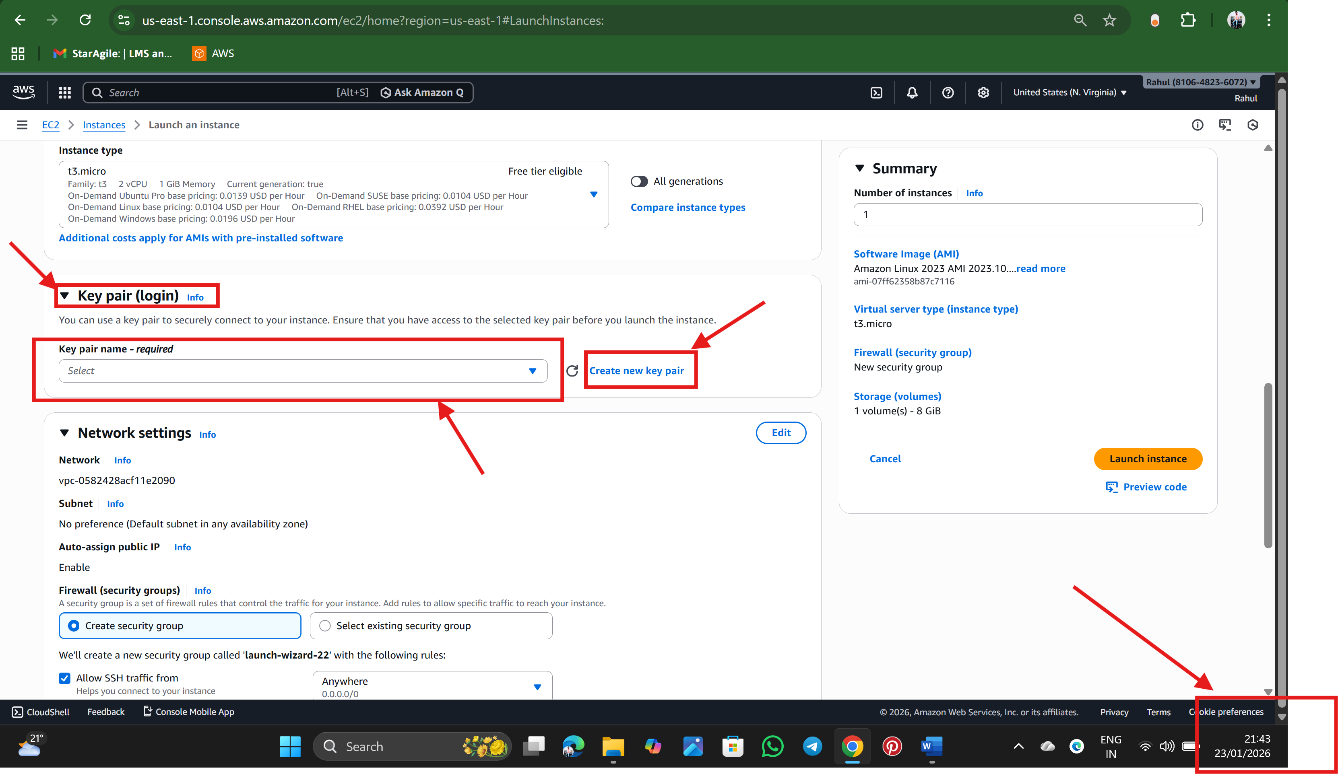

Step 7: Create a key pair with Name: key

Type: RSA

Format:

.pem for Linux/MobaXterm

.ppk for PuTTY

Click on create key pair

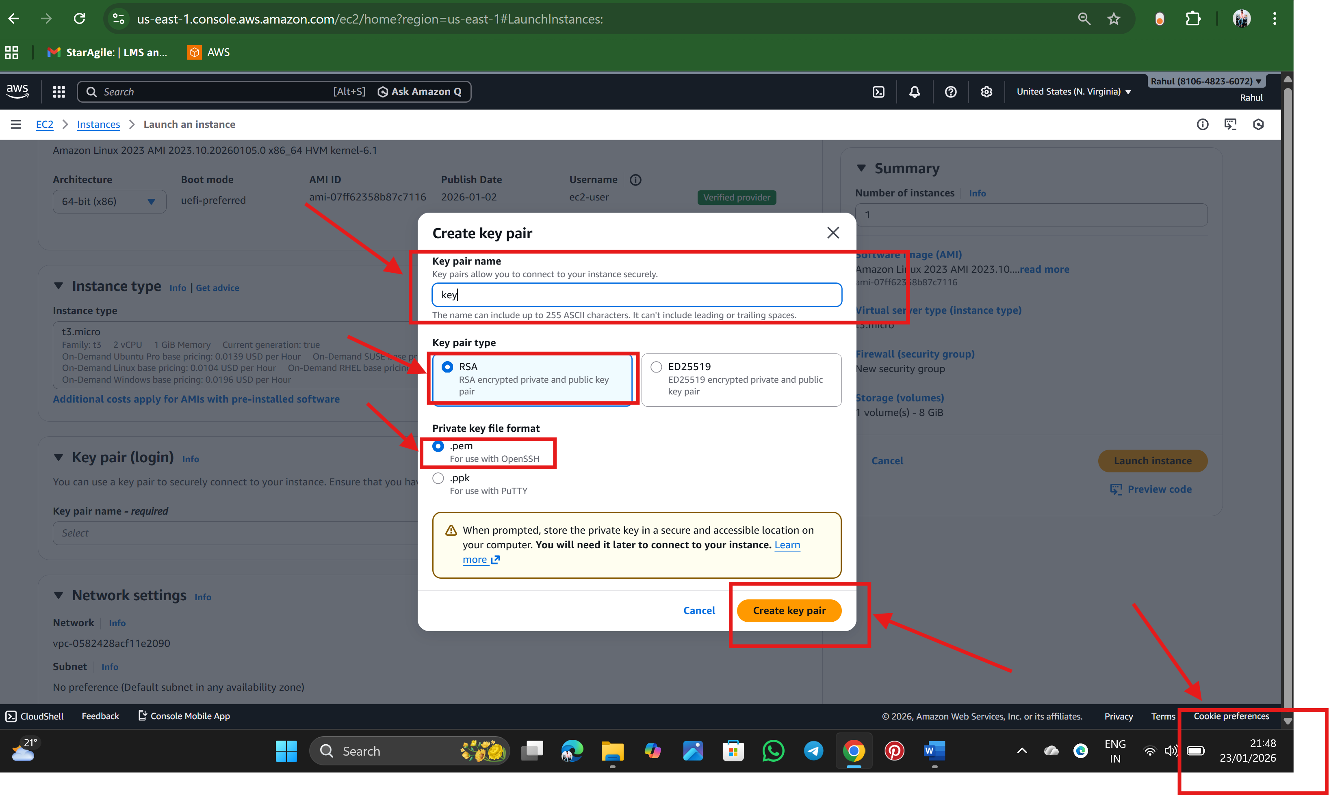

Download and save the key pair safely and we cannot download the key again.

Step 8: Configure Network Settings

* Allow SSH (Port 22)

Source:

* My IP (recommended for security)
* or Anywhere (0.0.0.0/0)🡪 we are keep this only for demo purpose only
* Allow HTTPS traffic from the internet
* Allow HTTP traffic from the internet

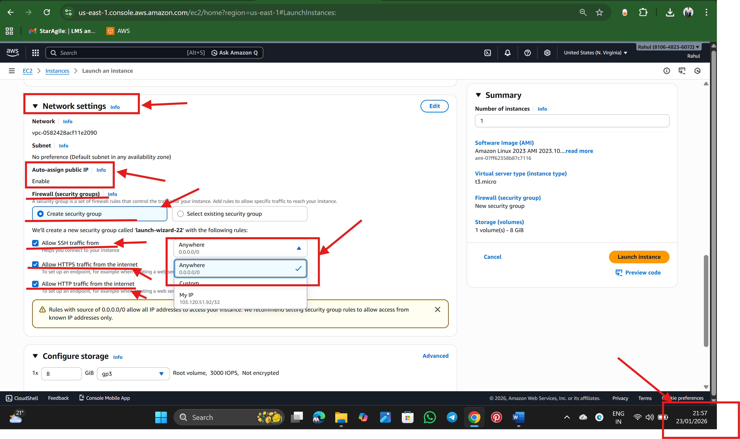

Step 9: Storage config , Default 8 GB is enough

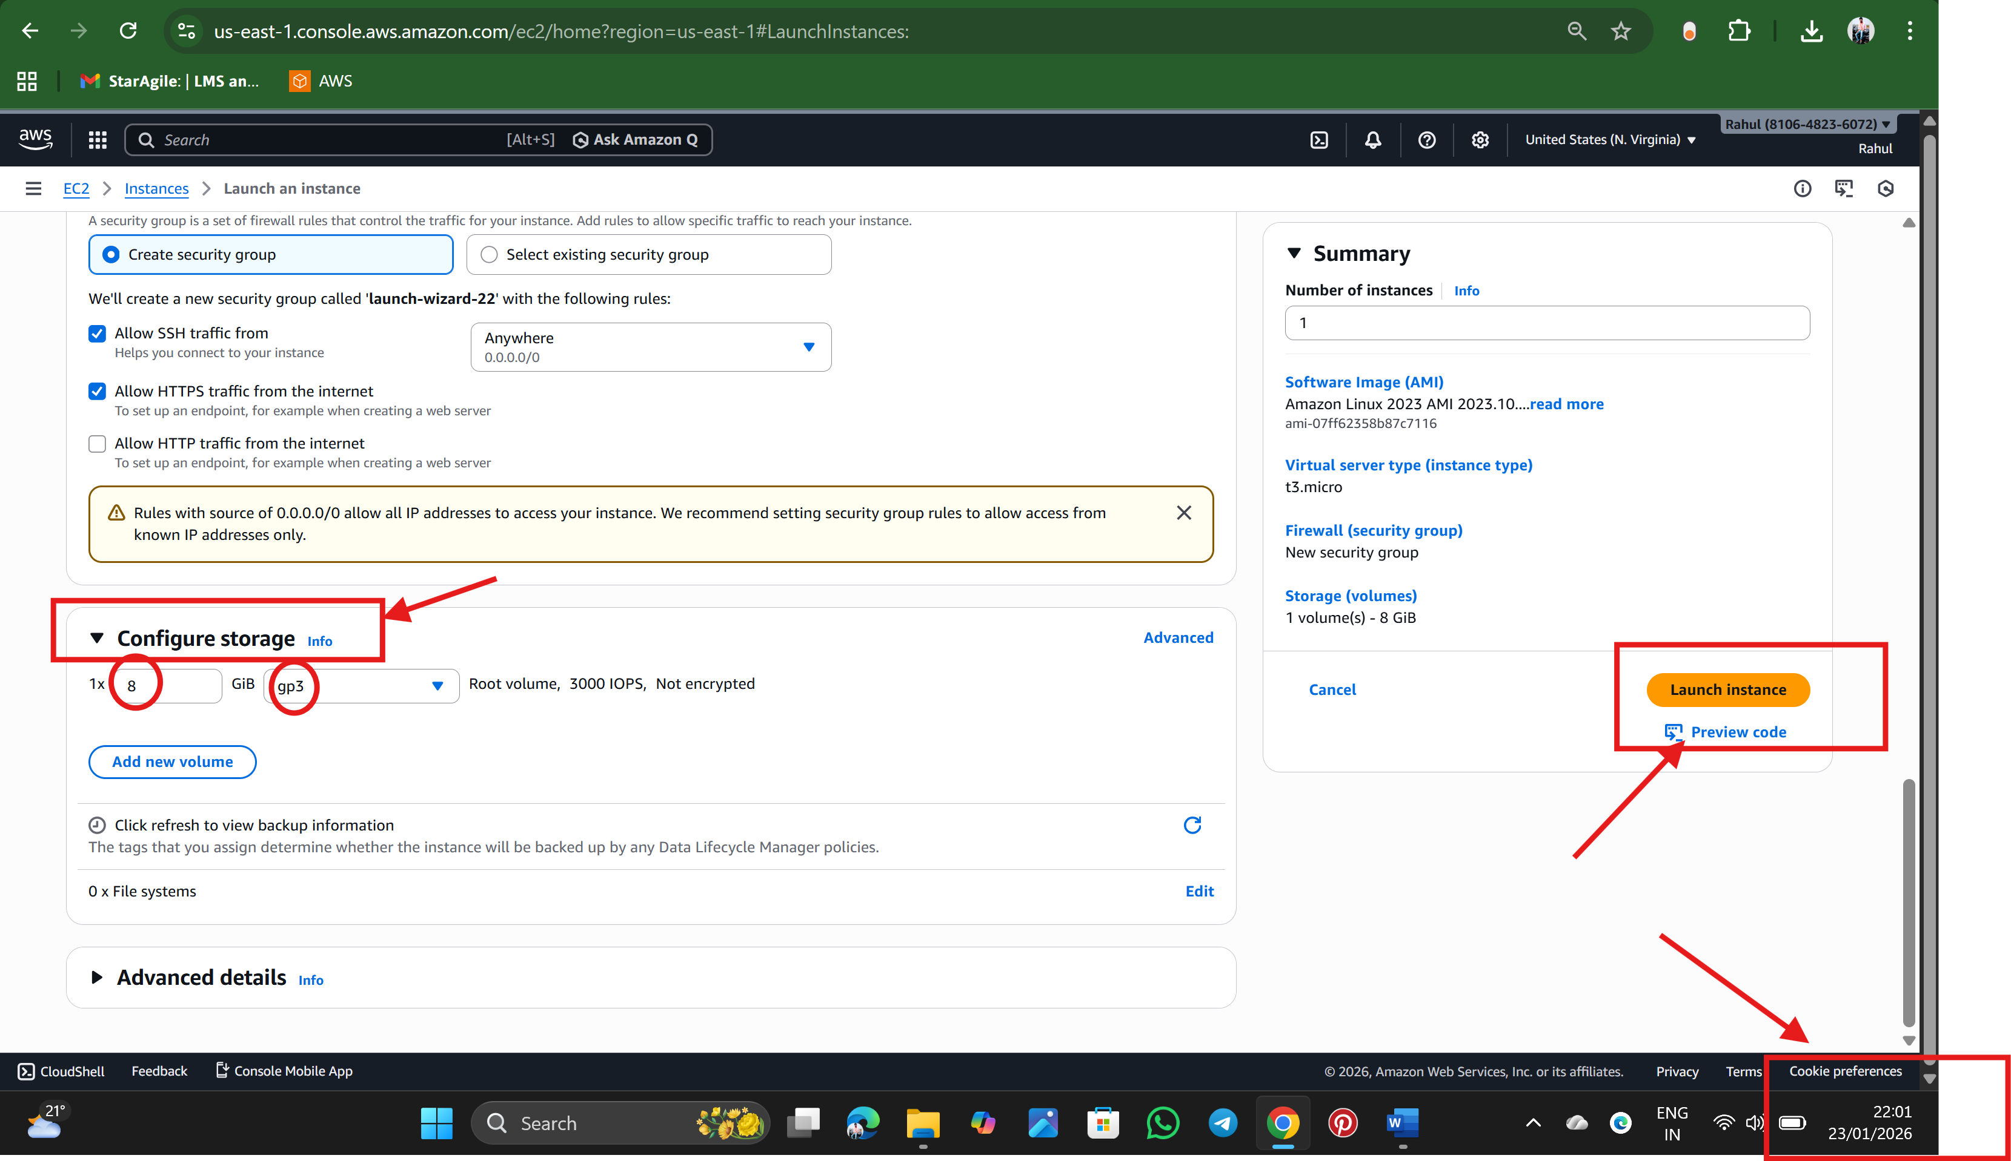

Click on Launch Instance

Step 10: The Instance is getting created

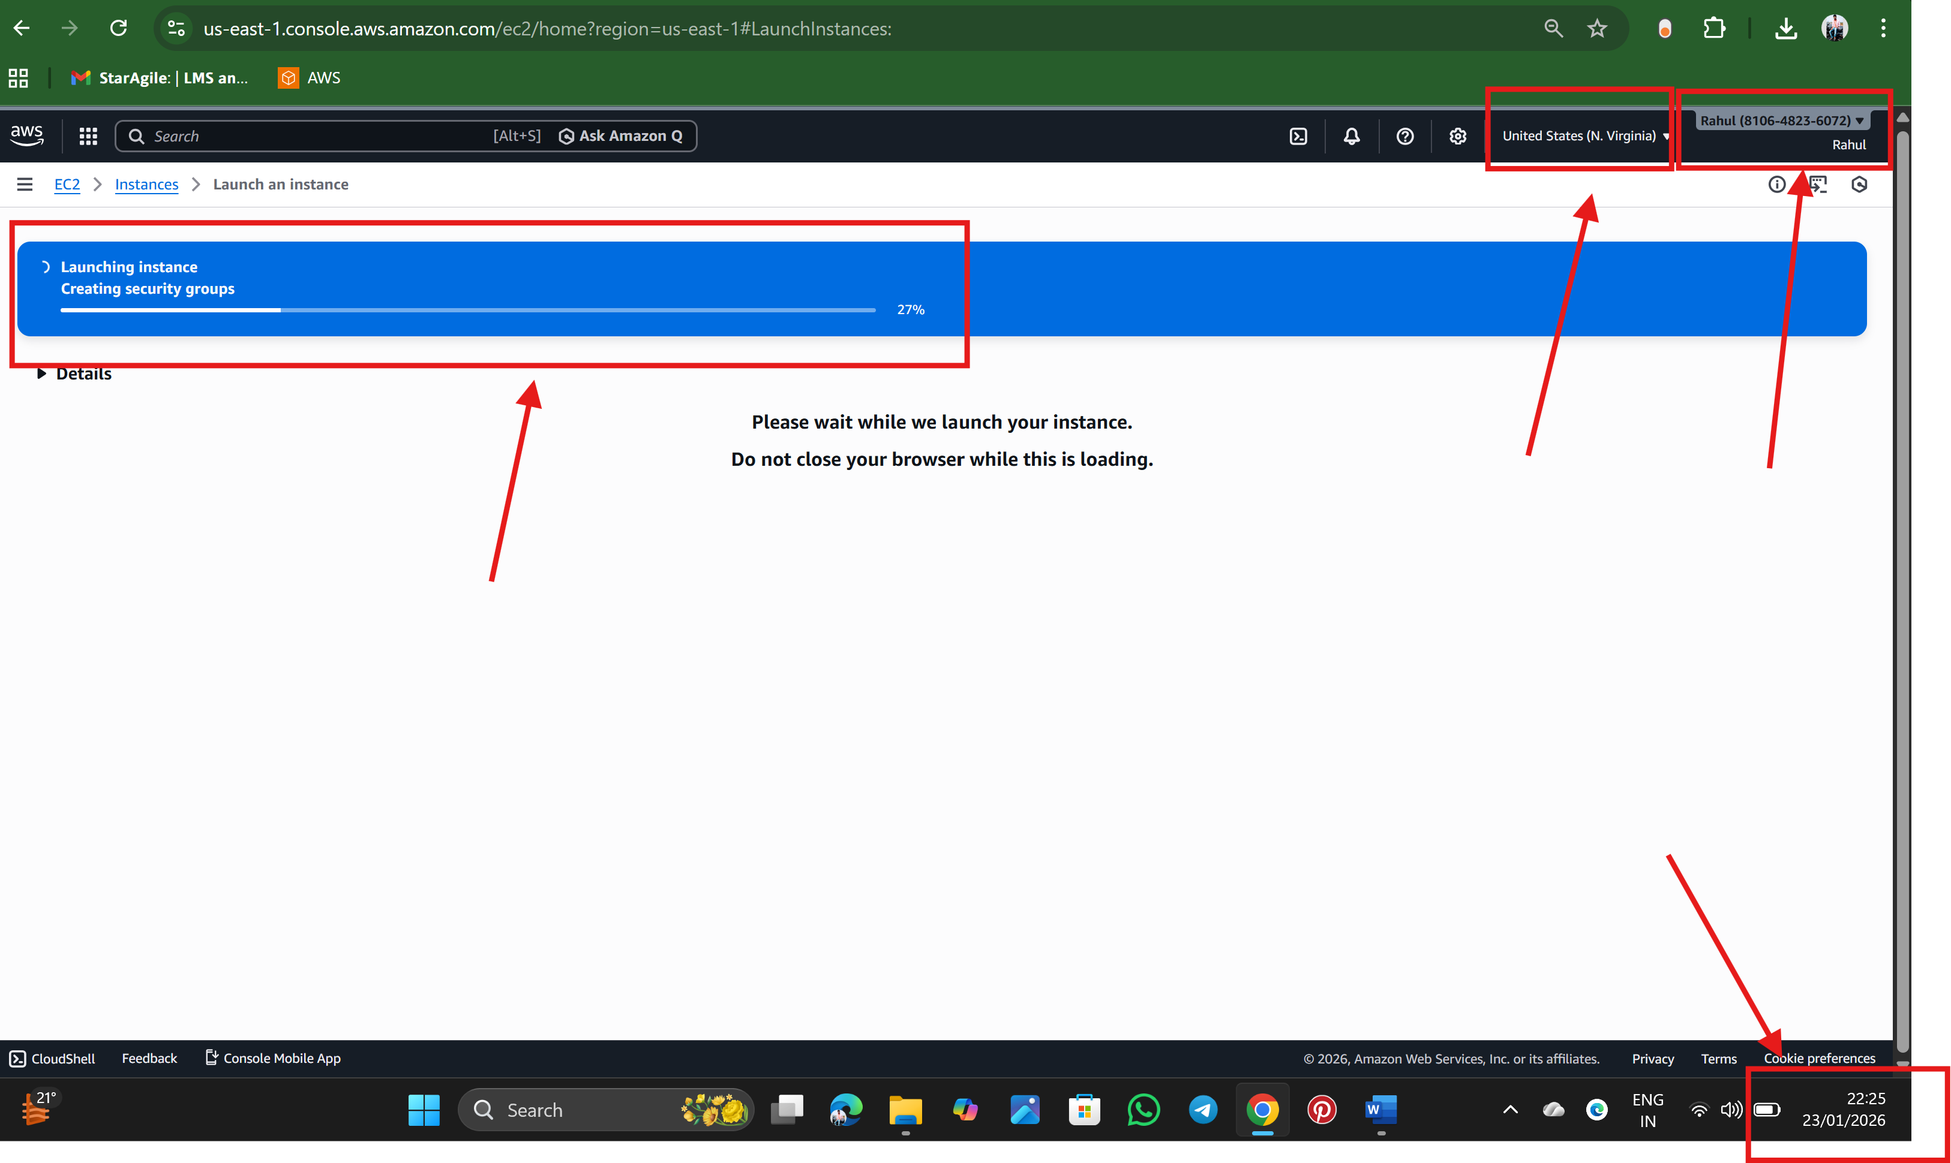

The Instance is created  
  
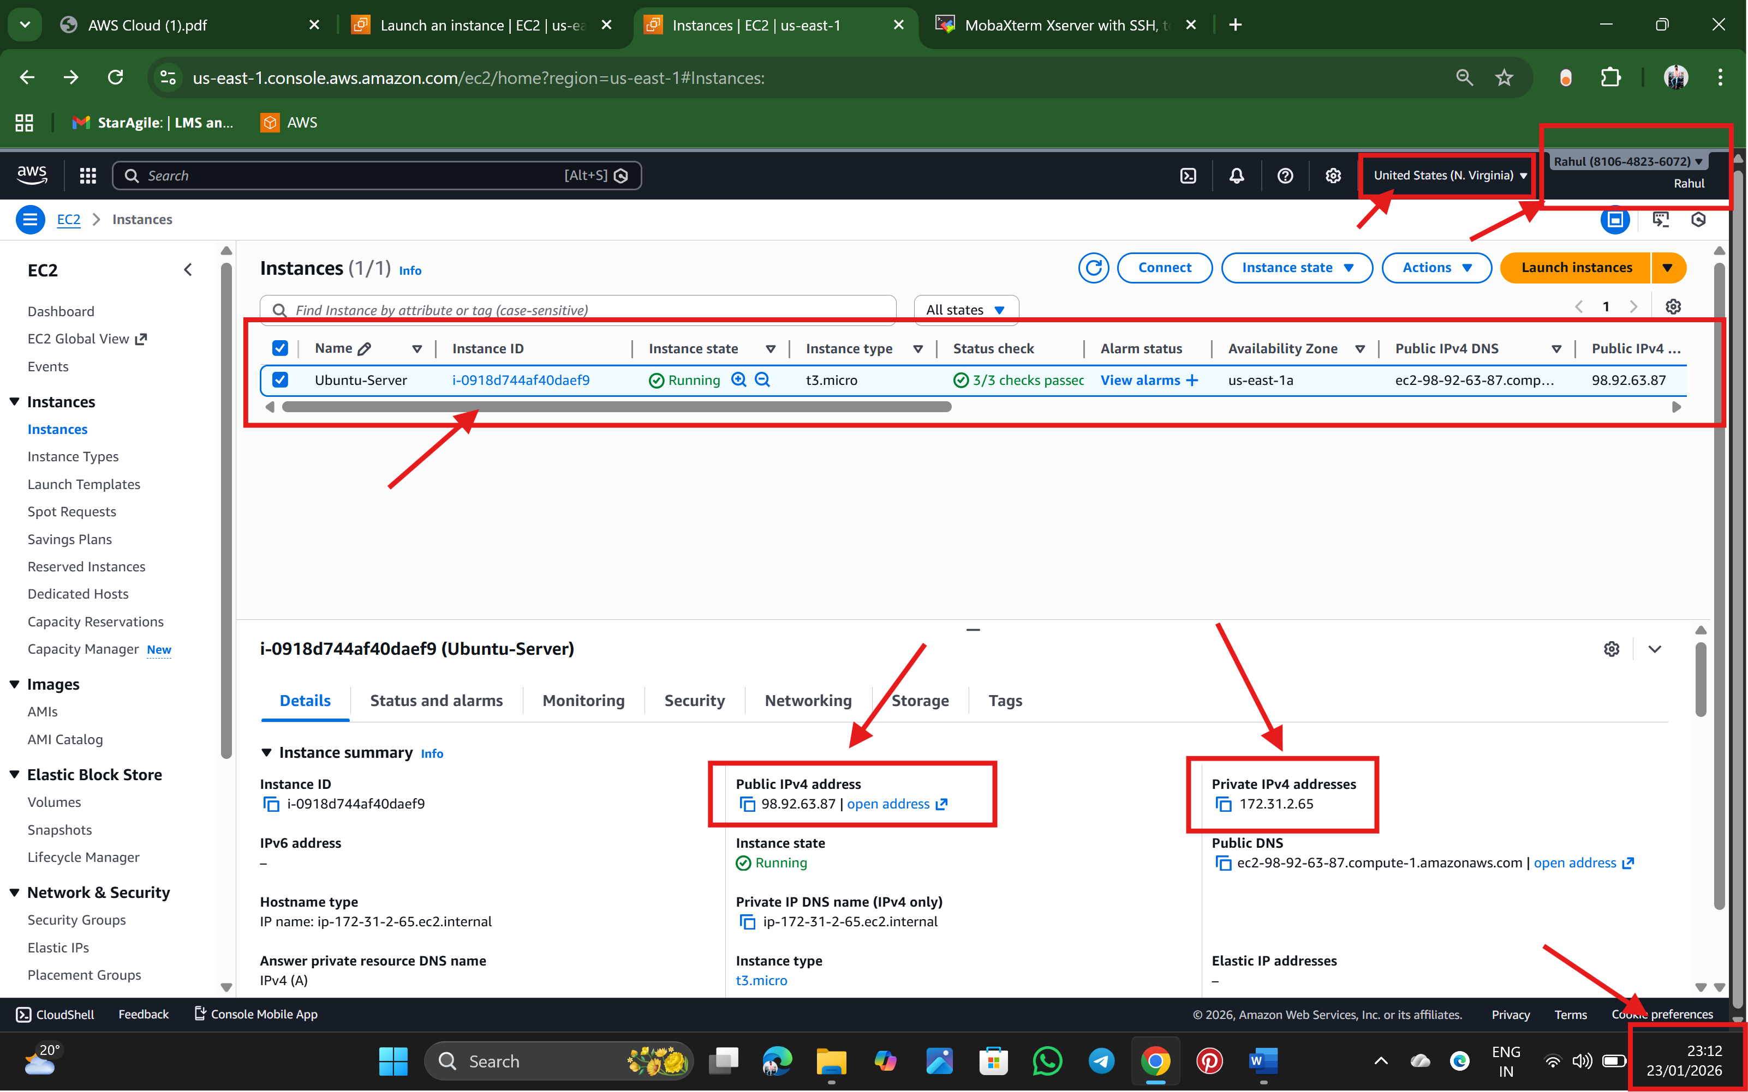

Step 11: Downloading the MobaXterm 🡪 <https://mobaxterm.mobatek.net/download-home-edition.html>

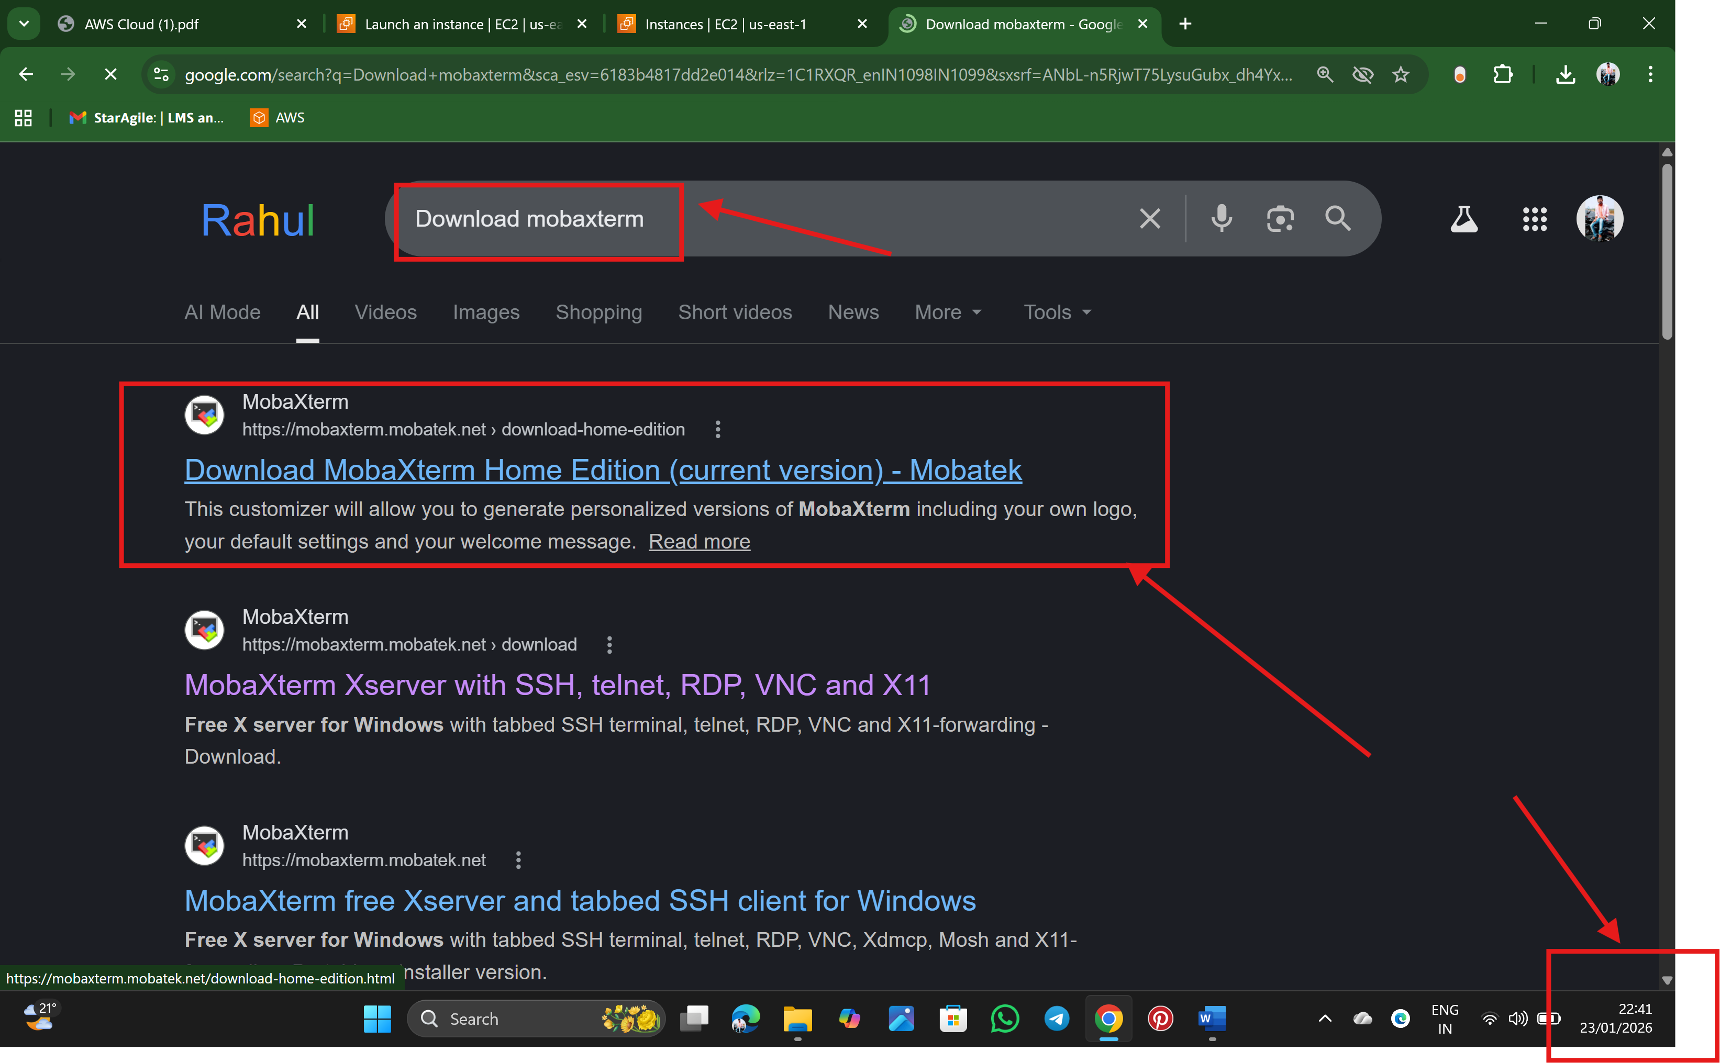

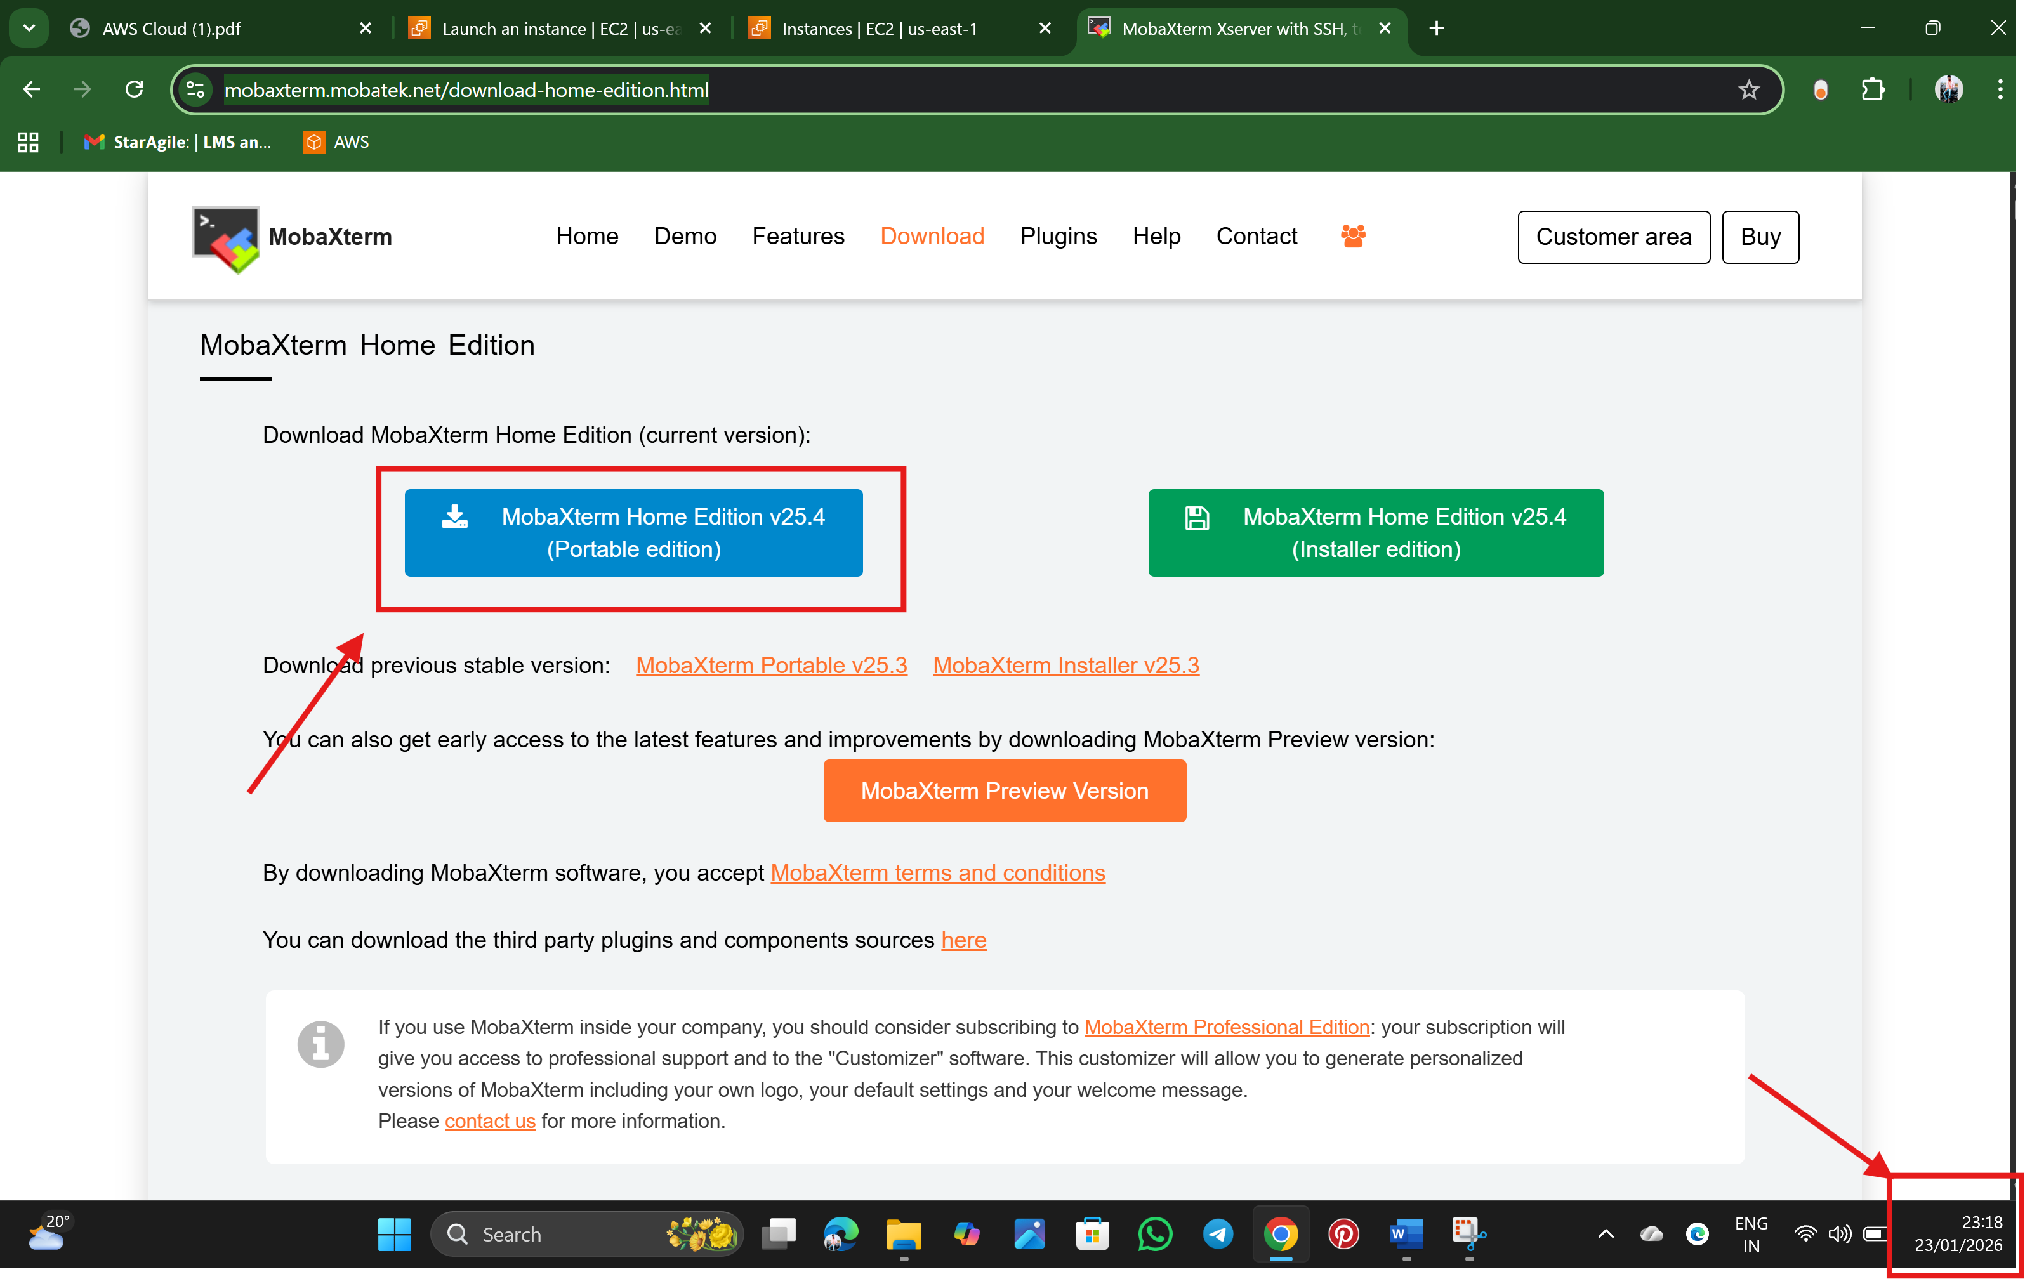

Step 12: Extract the zip file and open the MobaXtrem  
  
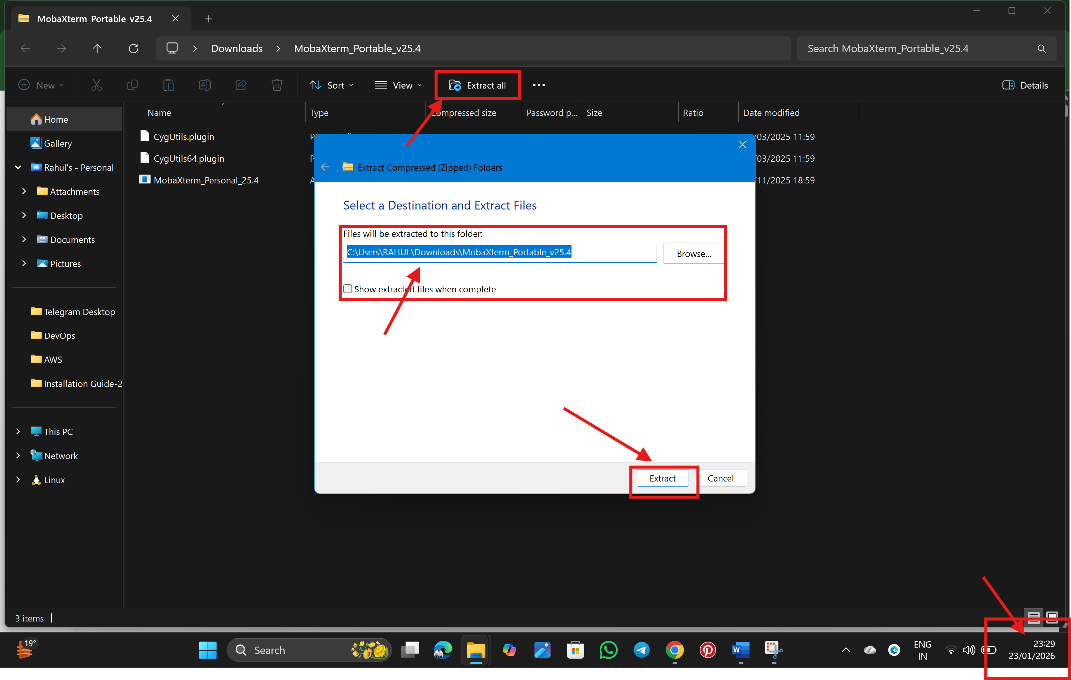

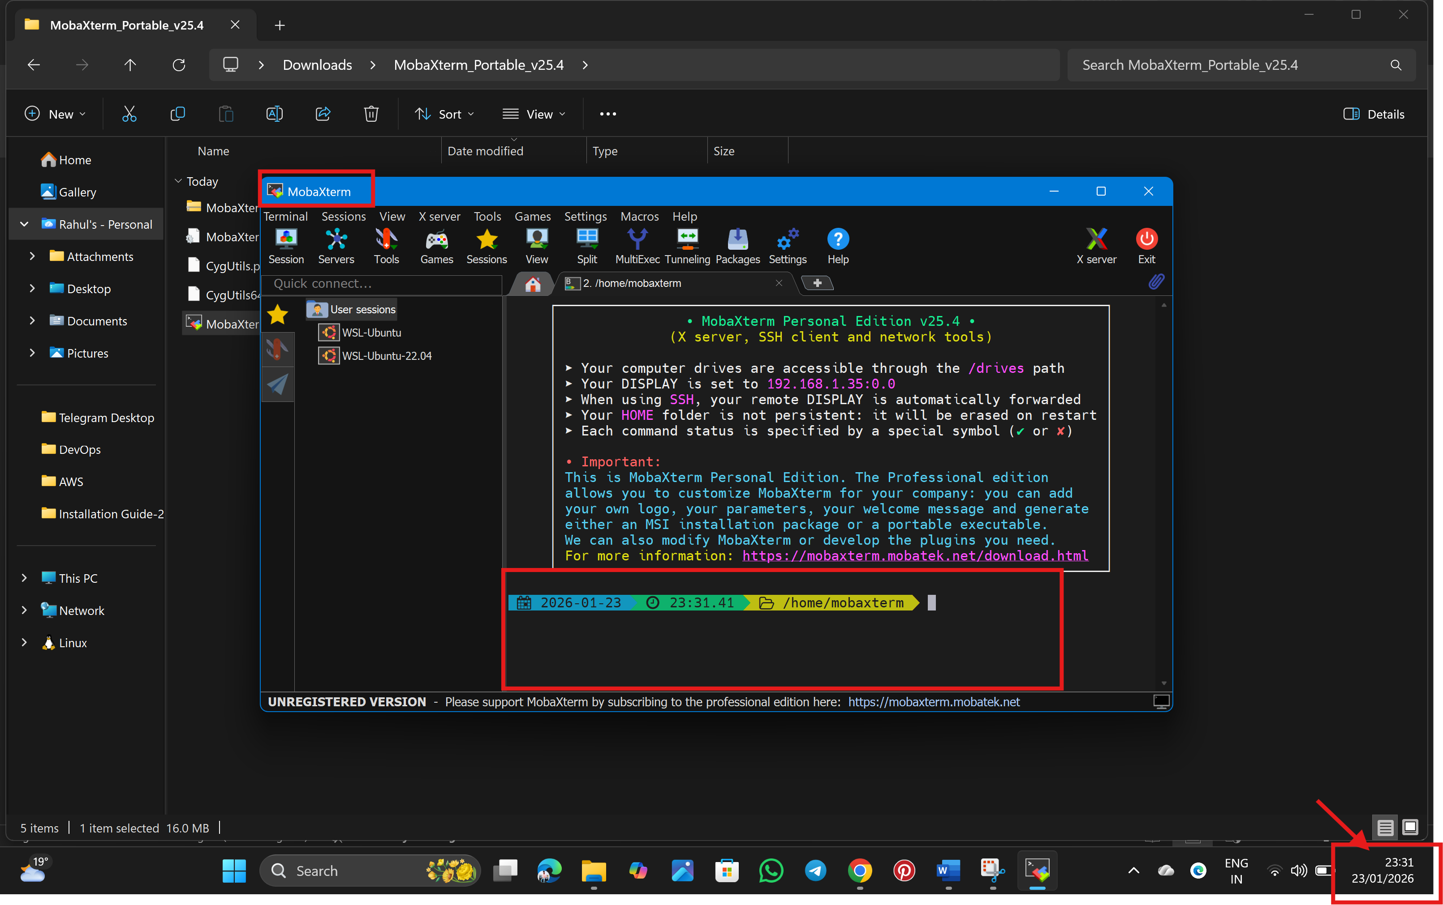

Step 13: click on Instance Id and click on connect

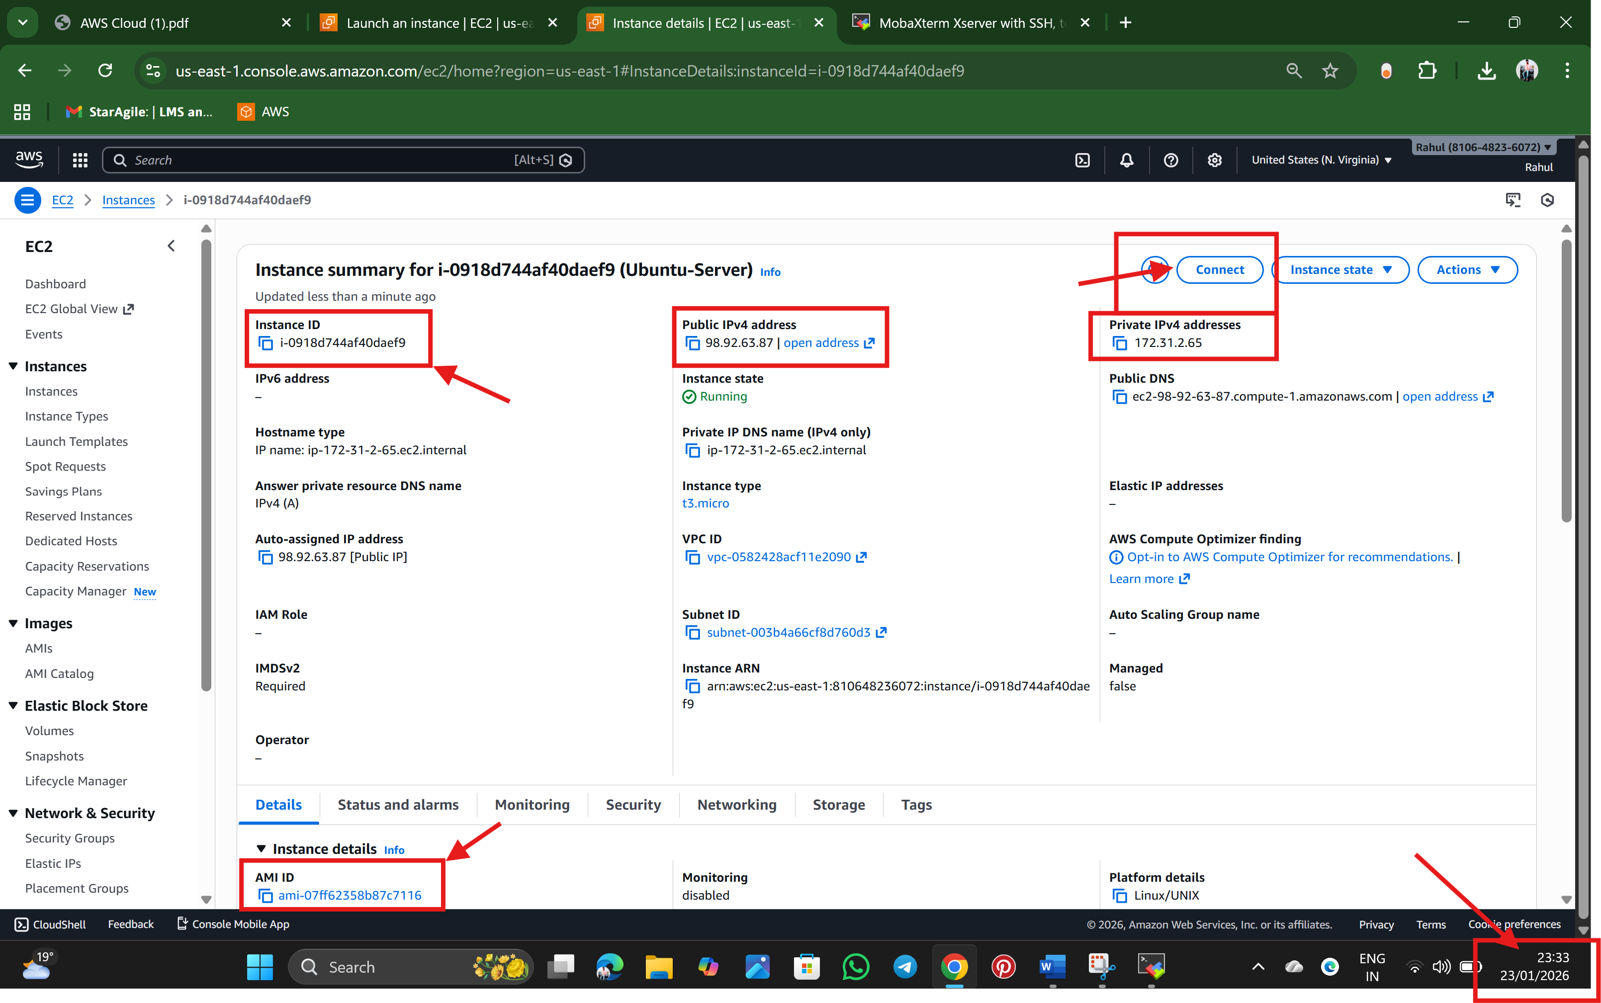

Step 14:Use ssh Client to connect to the server

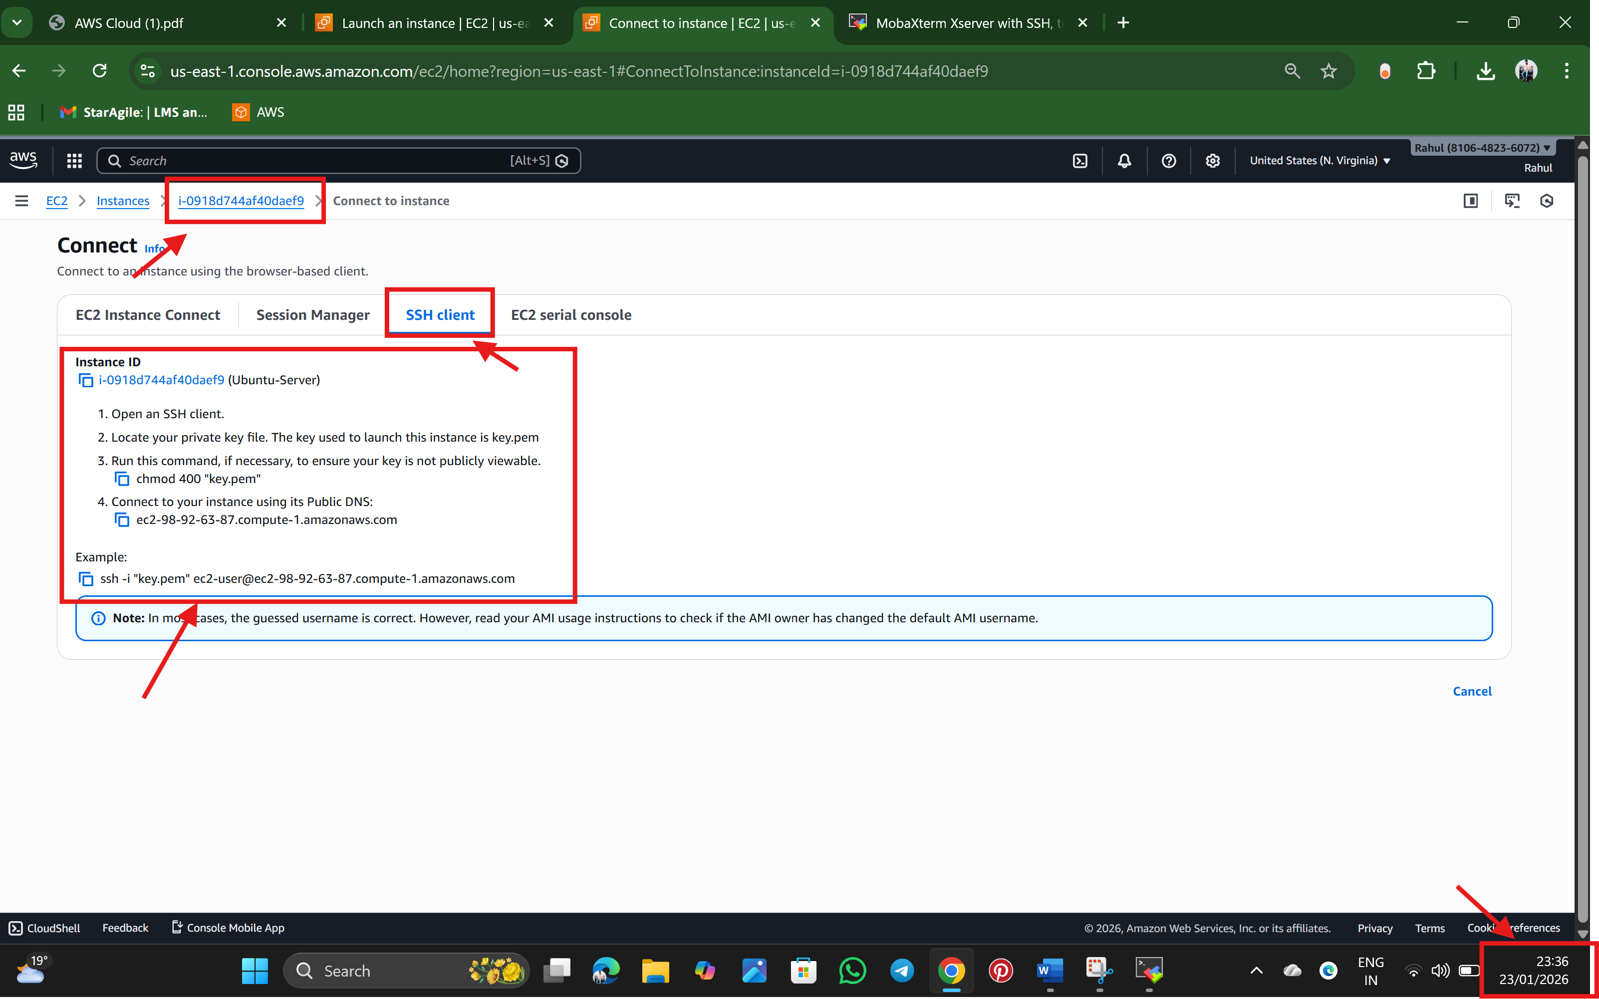

Step 15: Open MobaXtrem and go to the path where we have stored our key.pem  
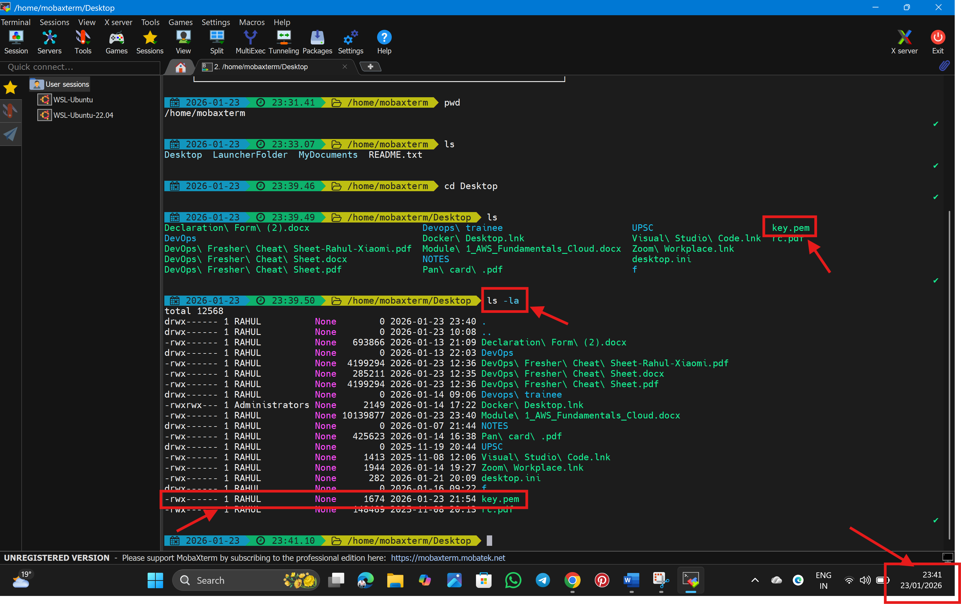

Step 16 : we have gone to the .pem key path and used ls -la command to see the permissions, for our key there are too open permissions like read, write, execute 🡪 so need to modify with only read permission 🡪 chmod 400 key.pem

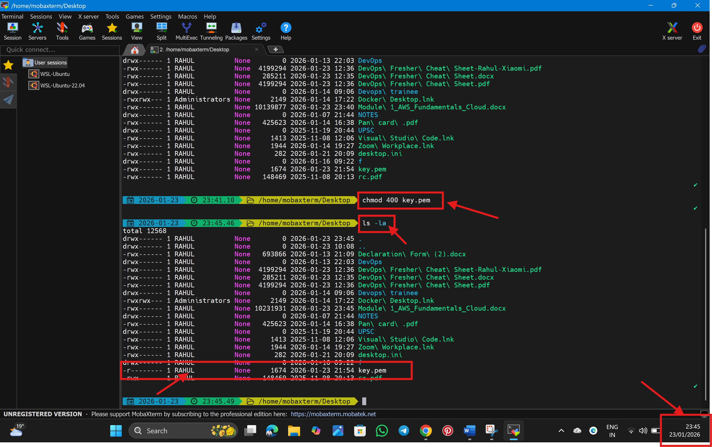Step: 17 Finally connected to the server using MobaXtrem  
  
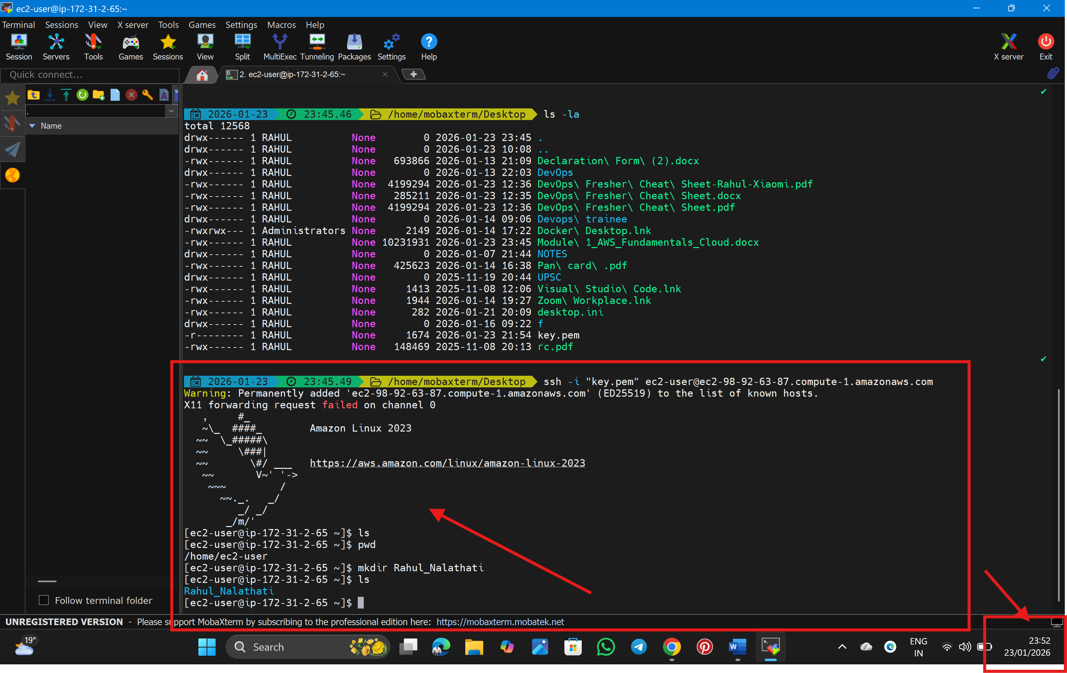  
X11 forwarding request failed on channel 0

Currently got this error but successfully login to the server, working on that error.  
I have tried with CMD, now its working fine.  
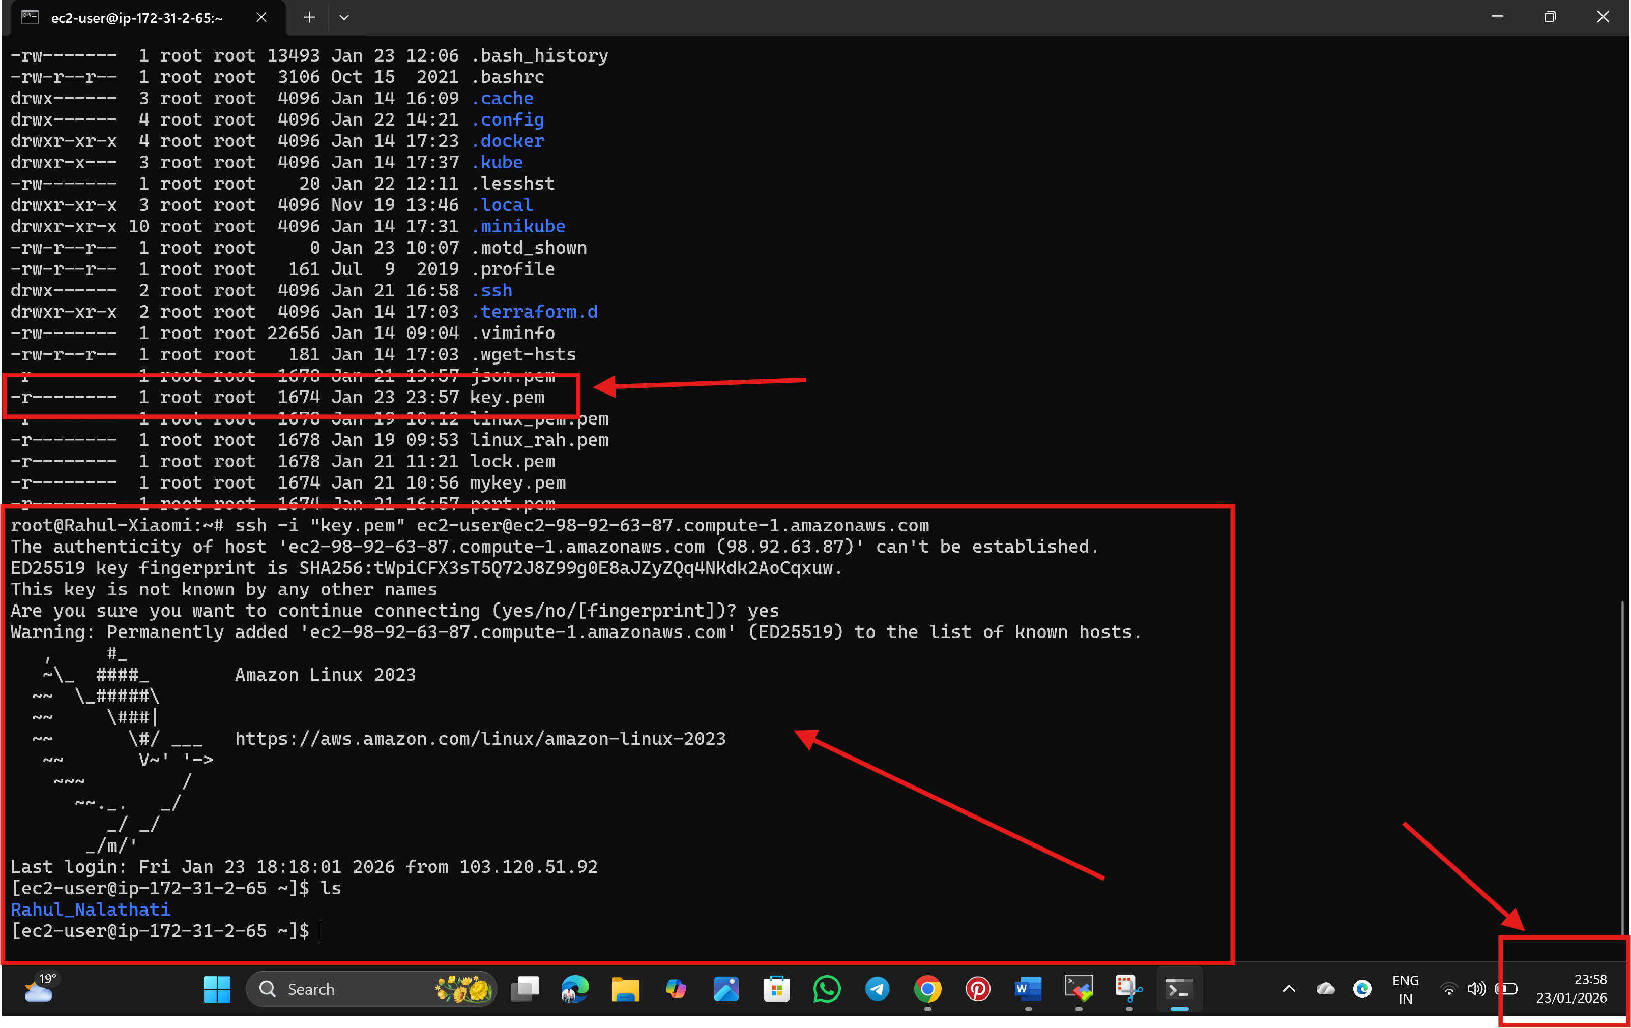

🡪Rahul Nalathati